Acquiring Bank
# Source: AI Source: Provided by: [Data Path: Persons Table -> ID Column: 1, Name_En Column: Motasem Essam] -> From: [ChatGPT] on [1/21/2026]
An acquiring bank (also known as a merchant bank) is the financial institution that provides businesses (merchants) with the ability to accept card payments. It plays a central role in the processing, authorization, and settlement of card-based transactions on behalf of the merchant.

🧠 Simple Definition
# Source: AI Source: Provided by: [Data Path: Persons Table -> ID Column: 1, Name_En Column: Motasem Essam] -> From: [ChatGPT] on [1/21/2026]
The acquiring bank is the bank that works with the merchant, helping them accept payments from cardholders, and receives funds from the issuing bank after successful transactions.

🎯 Key Roles of the Acquiring Bank
# Source: AI Source: Provided by: [Data Path: Persons Table -> ID Column: 1, Name_En Column: Motasem Essam] -> From: [ChatGPT] on [1/21/2026]
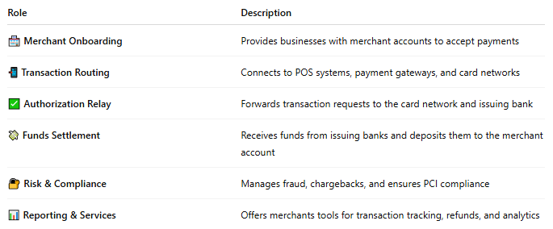

Role | Description
🏪 Merchant Onboarding | Provides businesses with merchant accounts to accept payments
📲 Transaction Routing | Connects to POS systems, payment gateways, and card networks
✅ Authorization Relay | Forwards transaction requests to the card network and issuing bank
💸 Funds Settlement | Receives funds from issuing banks and deposits them to the merchant account
🔐 Risk & Compliance | Manages fraud, chargebacks, and ensures PCI compliance
📊 Reporting & Services | Offers merchants tools for transaction tracking, refunds, and analytics

🔁 How It Works in a Transaction
# Source: AI Source: Provided by: [Data Path: Persons Table -> ID Column: 1, Name_En Column: Motasem Essam] -> From: [ChatGPT] on [1/21/2026]
Scenario: A customer pays with a card in your store
- Customer enters card details or taps the card.
- The POS/gateway sends the transaction to the acquiring bank.
- Acquirer sends the request via the card network (e.g., Visa) to the issuing bank.
- If approved, the issuing bank guarantees payment.
- The acquiring bank collects the funds and settles them into the merchant’s account.

📌 Examples of Acquiring Banks
# Source: AI Source: Provided by: [Data Path: Persons Table -> ID Column: 1, Name_En Column: Motasem Essam] -> From: [ChatGPT] on [1/21/2026]
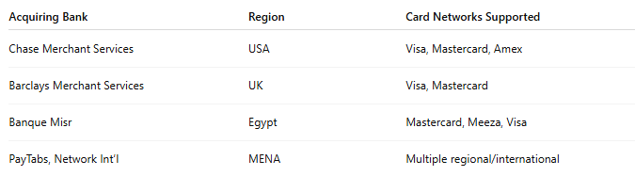

Acquiring Bank | Region | Card Networks Supported
Chase Merchant Services | USA | Visa, Mastercard, Amex
Barclays Merchant Services | UK | Visa, Mastercard
Banque Misr | Egypt | Mastercard, Meeza, Visa
PayTabs, Network Int’l | MENA | Multiple regional/international

✅ Why Acquiring Banks Matter
# Source: AI Source: Provided by: [Data Path: Persons Table -> ID Column: 1, Name_En Column: Motasem Essam] -> From: [ChatGPT] on [1/21/2026]
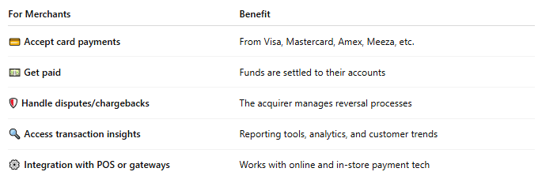

For Merchants | Benefit
💳 Accept card payments | From Visa, Mastercard, Amex, Meeza, etc.
💵 Get paid | Funds are settled to their accounts
🛡️ Handle disputes/chargebacks | The acquirer manages reversal processes
🔍 Access transaction insights | Reporting tools, analytics, and customer trends
⚙️ Integration with POS or gateways | Works with online and in-store payment tech

🔐 Acquiring Bank vs Issuing Bank
# Source: AI Source: Provided by: [Data Path: Persons Table -> ID Column: 1, Name_En Column: Motasem Essam] -> From: [ChatGPT] on [1/21/2026]
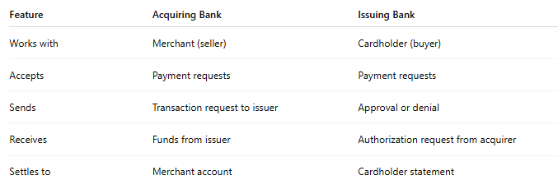

Feature | Acquiring Bank | Issuing Bank
Works with | Merchant (seller) | Cardholder (buyer)
Accepts | Payment requests | Payment requests
Sends | Transaction request to issuer | Approval or denial
Receives | Funds from issuer | Authorization request from acquirer
Settles to | Merchant account | Cardholder statement

🧠 Summary
# Source: AI Source: Provided by: [Data Path: Persons Table -> ID Column: 1, Name_En Column: Motasem Essam] -> From: [ChatGPT] on [1/21/2026]
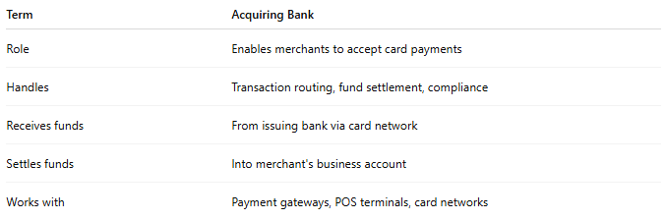

Term | Acquiring Bank
Role | Enables merchants to accept card payments
Handles | Transaction routing, fund settlement, compliance
Receives funds | From issuing bank via card network
Settles funds | Into merchant's business account
Works with | Payment gateways, POS terminals, card networks

